Ordering Supplies for the Exemplification of Charity, Unity and Fraternity (CUF)
Here are suggestions for ordering supplies for the CUF. We have purchased an entire set for each council in our District (152), although, if cost is a factor, you could get by with one per District and everyone can just share it. I keep all the candidate kits for the district and give them out as needed.
Ordering supplies for the CUF is somewhat inconvenient, because you may have to order items from 3 different places – Supplies Online, Knights Gear (both accessible from officers online) and the English Company (kofcsupplies.com).
The CUF has a total of 7 roles, including 5 major speaking roles – Presiding Officer, Presenters on Charity, Unity and Fraternity, and the Chaplain. In addition, there is an investing officer, which has some brief lines. There is also a warden, which is a non-speaking part.
Of the 7 roles, all but the Chaplain must wear the ceremonial baldric. Although officially all parts should wear suits, we typically ask the team to just wear council shirts and slacks with the baldric. In our opinion, this is more convenient for the team members, and projects more of a team aspect to promote unity and fraternity. In our CUF’s, we have usually had a deacon in the Chaplain role. The chaplain may choose to wear clericals (if a priest), an alb (priest or deacon), or a council shirt, with or without the baldric. When we have performed the CUF, our deacons have worn their council shirts WITH the baldric. Also, when we have had candidates from multiple councils, we invite the GK’s to invest their own Knights. When this occurs, we have provided baldrics for them as well. In summary, you should purchase at least 6 ceremonial baldrics, but I would recommend having two more on hand.
As for the Ceremonial Books, you can order a very nice, spiral bound book from Supplies Online, but these are a little pricey at $11.40 each. In the past, I have ordered 7 per council so that all roles, both speaking and non-speaking have them to familiarize themselves with their parts. If you don’t want to pay for the books, you can cut cost by downloading the book as a PDF and printing your own copies. If you do that, I would still recommend that you buy one copy of the bound book for use at the dais/ambo if your team will be reading the ceremony rather than memorizing it. For the Investing Officer (aka Grand Knight) part, he should memorize his two lines (not that hard).
For the crucifix, we have used the silver crucifix from Knights Gear, but you can use any crucifix as long as it is big enough to be seen when held aloft, and small enough to handle. The one from Knights Gear is a nice size and a classic look.
The cable and fibers are purchased from the English Company. Just order them as a set, as there are a LOT of fibers enclosed. You can re-order more fibers separately later if you ever run out.
Candidate kits include, among other things, the rosary and lapel pin that are used to invest the candidates. Buy plenty, as you can always save them for another day. I currently have 30 in stock for my District.

Here is a summary of where to purchase the needed items (prices do not include tax or shipping)
From Supplies Online (kofc.org, then Officers Online)
Candidates Kits – contain rosary, lapel pin, rosary card, Fr McGivney prayer card- order from Officers Online – Supplies Online Tab – then click on Ceremonial Supplies – then click on Council Ceremonial Supplies – then page 3 of those – then click on Candidates Kits - $3.50 each
Ceremonial Books – order from Officers Online – Supplies Online Tab – then click on Ceremonial Supplies – then click on Council Ceremonial Supplies – then page 1 of those – click on Combined Ceremonial Book – English OR Libro Ceremonial Combinado – Espanol - $11.40 each – can also be downloaded at no charge. (Picture below is of the bound version ordered online)
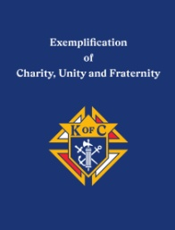

From Knights Gear (kofc.org, then Officers Online)
Crucifix – order from Officers Online - Knights Gear Tab – Silver Crucifix - $34.95
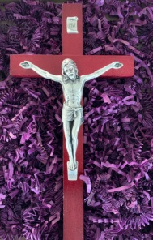

From The English Company – kofcsupplies.com
Ceremonial Baldrics - $26 ea – need 6-8 ($32 for extra length)
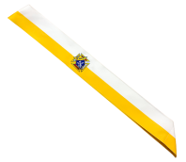
Cable and Fibers - $19
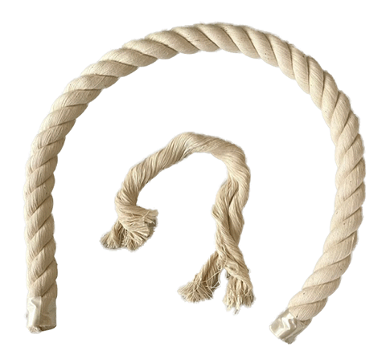
TOTAL COST not including candidate kits– minimum $186.40, maximum $341.75. Total shipping costs should run around $40-$50. Not all items are subject to sales tax. Add candidate kits @ $3.50 each.
In summary, you could get a complete set and 10 candidate kits for about $260. If you wanted a more “deluxe” set-up, and 20 candidate kits (for example), it would run about $480. The cost could be per council (if every council wants their own set), or for the entire district (each council could chip in their share). In addition, you probably should purchase a plastic tub or other container to hold each kit (see below).

